A. Look at the picture and write sentences using THIS , THAT , THESE , THOSE.

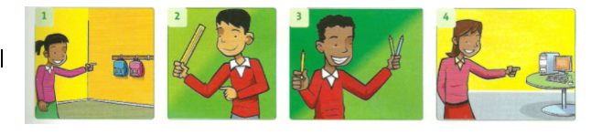
- _______________________
- _______________________
- _______________________
- _______________________

____ / 4

B. Answer these questions

1. What is your favourite toy ?

2. Do you like games?

3. Are you an alien?

4. Can you play the violin?

____ / 4

C. Look, read, and complete.

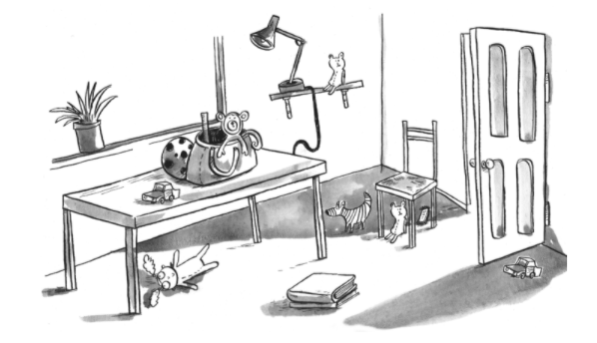
1. _______________________the lamp? It’s the shelf.
2. _______________________the teddy bear? It’s_______________________ the chair.
3. _______________________the car? It’s _______________________ the door.
4. Where is the _______________________? It’s on the table.
5. _______________________the ball? It’s _______________________ the bag.
6. Where is the _______________________? It’s _______________________ the _____________.

____ / 6

D. Complete the instructions with the words in the box.

UP – LOOK – LISTEN – DOWN – UNDER – DON’T

1. Don’t stand _____________ .
2. Sit ____________ on the bed.
3. _____________open the closet.
4. _____________on the shelf.
5. Don’t look _____________ the sofa.
6. _____________ to me, please.

____ / 6

E. Unscramble the sentences.

1. have / toys. / I / three ___________________________________________

2. and / a / I / a / car. / bike / have ___________________________________________

3. have / computers. / I / two___________________________________________

____ / 3

F. Look at the table and write sentences.
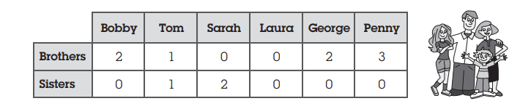
YOU
Brothers
Sisters

1.Bobby ______________two brothers. ____________ names are Joe and Fred.
2 Tom ____________________a brother and a sister.
3 Sarah _______________ two sisters. _____________names are Sue and Casey.
4 Laura ______________ have brothers or sisters.
5 George __________________ two brothers. ___________________names are Billy and Jonny.
6 Penny ______________________any sisters but I three brothers.
7. I ______________________________________________________________________ .
____ / 7

G. Write answers.

1. Have you got any brothers or sisters? ✔ ______________________________ .
2 Have you got any uncles? ✘ _______________________________________ .
3 Have you got any grandpa? ✔ __________________________.

____ / 3
H. Write T (true) or F (false). Correct the false ones.

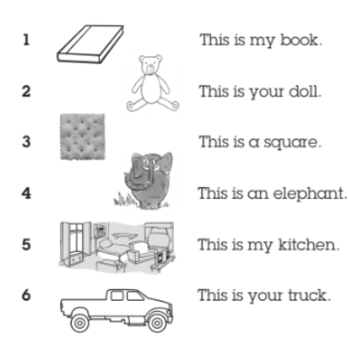
- _________________________________________________
- _________________________________________________
- _________________________________________________
- _________________________________________________
- _________________________________________________
- _________________________________________________

____ / 6
H.Dictation

1._______________________________________________________________________________
2. ______________________________________________________________________________
3. ______________________________________________________________________________
4. ______________________________________________________________________________
5. ______________________________________________________________________________
6._______________________________________________________________________________
7. ______________________________________________________________________________
8. ______________________________________________________________________________
9._______________________________________________________________________________
10.______________________________________________________________________________

