Buckingham House

Name:

Mid-term exam

August 2020

Read the instructions carefully to do each exercise. Please remember to write **IN BLUE!**

Good luck ☺☺

1. **Complete the following sentences using the simple present or the present continuous of the verbs in brackets.**
2. Kathy always __________(smile) in class and at the moment some of the other kids ________________ (smile) as well.
3. Right now the kids______ (read) a book and the teacher _______________ (to write) on the board.
4. Almost every day class______ (begin) at 8:00, but on Tuesdays the class _______ (start) at 8:30.
5. ____She_____ (like) to bake cookies, but at the moment she _________ (not bake) cookies because she_________ (study) at school.
6. Danny______ (enjoy) climbing mountains during his vacation, but this year he_______ (not take) any vacation because he_______ (study) English.
7. **Look at the pictures and write FULL sentences in the correct tense.**

**What did they do yesterday?**

1. 
2. 
3. 
4. 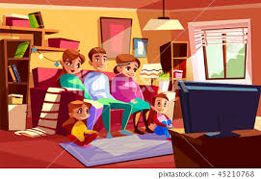
5. 
6. 
7. 
8. **Choose the correct option.**
9. **Hector______ to some opera last Sunday.**
10. listen ii) listened iii) listens
11. **My brother_____his car.**
12. Sell ii) sold iii) selling
13. **Everyone______the exercises from the board.**
14. Copy ii)copied iii) copying
15. **Edgar_____all the presents.**
16. Open ii) opened ii) opens
17. **Sheila____ the police station.**
18. Call ii) called iii)calling
19. **Where did he __ her?**
20. Meet ii) meets iii)met
21. **Mark_____to come back soon.**

i)promise ii)promised iii)promising

1. **Complete the sentences with SOME or ANY.**
2. There are……… bananas on the table.
3. Are there……..beans?
4. There is………….coffee in the cupboard.
5. There isn’t………….orange juice in the fridge.
6. Is there……milk in the cups?
7. There aren’t………..potatoes in the kitchen.
8. **Put some or any into the gaps.**
9. I don’t have _____money in my pocket, but I have ____ money in the bank.
10. Are there ______ letters for me this morning?
11. I never have _______breakfast. I’m not hungry in the morning.
12. You have _____ lovely pictures in the house.
13. **Put the verbs in brackets into the PAST SIMPLE.**

Pamela: What….*did you do…*(you/do) last weekend?

Tony: I ……….(go) to my cousin’s house.

Pamela: ………………(be) it far?

Tony: No, it only……(take) us 30 minutes.

Pamela:…………… (you/stay) there long?

Tony: We……(stay) only for the weekend. What ……….. (you/do) last weekend?

Pamela: My family and I ….. (take) the dog and we ……….. (have) a picnic on the beach.

Tony: ……….. (be) it sunny?

Pamela: Yes, the sun shone all day. We………. (take) pictures, look!

1. **Complete the sentences with HAS TO-HAVE TO- DON’T HAVE TO- DOESN’T HAVE TO. The sentences that have X are negative.**
2. He _____use pencil at school.
3. I ______feed my hamster.
4. You_____take photos.
5. Vicky_____read the newspaper.
6. The teacher ______correct a lot of homework.
7. He _____work in the evening. **X**
8. We_____go shopping. **X**
9. My friends ______get up early.
10. Mandy ________read the instructions.
11. You ________do the project.
12. **Look at the pictures, ask and answer the questions to know the price.**

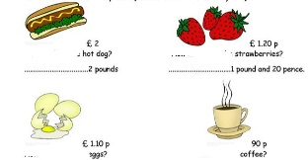

1. ………..hot dog?
2. ………strawberries?
3. ……….eggs?
4. ……..coffee?
5. **Look at the pictures and write the prices in letters.**

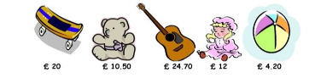

1. The skateboard is…………
2. The bear is………..
3. The guitar is………….
4. The doll is………..
5. The ball is…………
6. **Put the verb In brackets in the correct tense: Present simple, past simple or present continuous.**
7. I usually _________ (watch) TV after dinner.
8. She ____________ (not jump) at the moment.
9. What ______ Tom ______ (read) every day?
10. She _____ (answer) all the questions in yesterday’s test.
11. Who __________ (listen) to the radio now?
12. ________ you _____(forget) something?
13. We ________(eat) breakfast everyday at 7 o’clock.
14. He _____ (drive) to work now.