GRAMMAR
1. Fill in the verbs in brackets in Present Continuous or Present Simple. Do not use contractions in this exercise.
1. What is he doing? He ______________at his desk. (sit)
2. Listen, someone _______________________ at the door. (knock)
3. On my way home I usually ____________________ to drink a cup of coffee. (stop)
4. Architects _______________________ plans of the buildings. (make)
5. Look at Betty!! she ________________ the piano. (play)
6. At this moment I _______________________ my pupils' exercises. (correct)
- Complete the sentences. Put the verb in brackets in the past simple or the past continuous.
- It _______________ (not snow) when I went to bed.
- When _______________ she _______________ (pass) her driving test?
- Donna _______________ (not come) to the theatre with us last night.
- What _______________ you _______________ (do) at six o’clock last night?
- I _______________ (not study) when you rang.

- Complete the email. Put the verb in brackets in the present perfect or past simple.
Hi Craig
I___________________ (just / receive) your email. Sorry to hear you aren’t well. I hope you feel better soon. You ¹_______________ (be) really busy recently!
²_______________ (you / plan) your holiday yet? In June, I ³_______________ (go) to Canada with my family again. We ⁴_______________ (go) there three times now! But this time, we ⁵_______________ (not stay) with my uncle in Toronto. Instead, we ⁶_______________ (hire) a car so we could visit different places. Then in August, Tanya and I ⁷_______________ (travel) around Morocco. ⁸_______________ (you / ever / go) there? It’s a really interesting country.
Write soon!
Tobias
- Look at Fred’s plans for the next week and write 5 sentences using Be + going to and the phrases below.
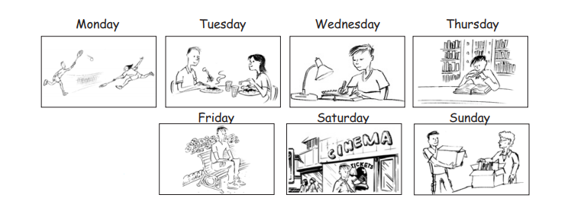

- invite a friend for lunch
- do his homework
- go to the library
- go to the park
- play tennis
- help his grandma
- see a film

1 _______________________________________________________________
2 _______________________________________________________________
3_______________________________________________________________
4 _______________________________________________________________
5 _______________________________________________________________

- Complete the text with the correct form of the verbs. (Present Simple – Present Continuous – Past Simple – Past Continuous – Present Perfect )

The Smiths ______________ (live) in a house. They usually _____________ (watch) TV in the living room. The father always _____________ (cook) food in the kitchen.
One day, while they ____________ (eat) in the dining room, they ______________ (see) a dog in their garden. They _________________ (decide) to keep the dog, and they called him “Buddy”. Since that moment, Buddy ___________________ (live) with The Smiths in a lovely family. Now, they _____________________ (wait) the their first child.

- Complete the dialogues with just, already, or yet.

1 Ana I haven’t emailed Yoshio ¹ __________. What about you?
Tim I’ve ² __________ sent him five emails!
2 Bob I’ve ³ __________ seen this film. I saw it at the cinema.
Jill Don’t tell me what happens! I haven’t seen it ⁴ __________!
3 Jan I’ve ⁵ __________ made some biscuits. Would you like one?
Lee No, thanks. I’m not hungry. I’ve ⁶ __________ had lots to eat today.
- Complete the following exercise with FOR or SINCE.

1- Nobody has come to see us ___________ we bought this small house.
2- She has been a doctor ___________ 1998.
3- Nobody has seen her ___________ then.
4- They have all been ill ___________ last week.
5- Peter went to the library. He has studied there ___________ a long time.

- Colour the correct word.

- She didn’t do nothing / something / anything yesterday.
- I knocked on the door but somebody / nobody / anybody answered.
- We’ve bought you something / somebody / somewhere for Christmas
- I’m thirsty because I’ve had something / nothing / anything to drink.
- Did you go anywhere / nowhere / anything nice at the weekend?
- Anyone / Someone / Something left their wallet in the classroom.
- I want to take Mum somewhere / anywhere / nowhere nice for her birthday.

- Colour the correct word or phrase.

1. All of my friends has / have / are have good jobs.
2. We don’t know / doesn’t know / not know Kerry very well.
3. What time finishes Dave / Dave finishes / does Dave finish work?
4. Listen! Someone playing / is playing / he’s playing the violin.
5. Tom and Kate not working / aren’t working / no are working today.
6. Why you’re using / you using / are you using my computer?
7. I’m really hungry. I haven’t eaten / didn’t eat / don’t eat yet.
8.They arrived / have arrived / arrive a week ago.
9. We have worked / worked / work here for three years.
10. They didn’t recognise / haven’t recognised / don’t recognise me at yesterday’s meeting.

